  EMIRATES CENTER FOR WILDLIFE PROPAGATION  Province de Boulemane - B.P. 47  33250 Missour  ROYAUME DU MAROC  Tél. : +212 (0)5 35 58 57 52  Fax : +212 (0)5 35 58 52 06  E-mail : houbara@ecwp.net.ma |  |  | Protocol | Identification: (update the value under)  250709_Habitat survey using the phytosociological method in Morocco
Habitat survey USING the phytosociological method  - Morocco - |  |  |  | Created on:  19/12/2011
Last update on:
05/08/2025

Number of pages:
12
Written by:  Mathieu CHAMBOULEYRON  Jean-François LÉGER | Reviewed by: | Approved by: |  | Center: ECWP  Departement: Ecology and Conservation
Access to the file (update value here after): W:\Ecologie\Public Ecologie\HHS\Botanique-Végétation\1_Recherche\1_Etudes & suivis\2_Phytosocio\_Protocoles et formulaires\250709_Phytosociological inventory in Moroccol.docx
Diffusion:

Contents
I. Preamble 4
II. Objectives 4
III. Material and methods 5
III.1. Study area 5
III.1.a. General characteristics 5
III.1.b. Sampling strategy and plan 6
III.1.c. Study planning 8
III.2. Field study 8
III.2.a. Requested material for field survey 8
III.2.b. Field prospections 9
III.2.c. Vegetation homogeneity 9
III.2.d. Data collected in each phytosociological relevé 9
III.2.e. Prevention of pseudo-replication 10
III.2.f. Additional plant observations 11
III.2.g. Plant collect 11
III.3. Data entry 11
IV. Bibliographic resources 11
V. Supplementary documentation 11
VI. Scientific partnerships 11
VII. References 12

Preamble
Since the study areas are wide, we had to select a lightweight method of characterising vegetation (compared, for example, to the removal of and weighing of plant aboveground biomass), to get data covering vast areas. On the other hand, we wanted to use a standard, well-known method (especially in SW Europe and North Africa), allowing to integrate data produced by tiers, and to facilitate the training of new joiners. The method of the phytosociological relevés matches these needs, producing semi-quantified data.

NB: Phytosociology is the study of plant communities from floristic, ecological, dynamic, chorological, and historical perspectives (GUINOCHET, 1973). It is the science of plant assemblages, organized into a hierarchical system, the synsystem, in which the fundamental elementary unit is the plant association (MEDDOUR, 2011). "An association is a plant community characterized mainly by a specific and relatively stable floristic composition within the limits of a given area; every association represents a more or less stable stage of varying duration in a progressive or regressive series of associations" (ALLORGE, 1922).
There are two main schools of phytosociology: synusial phytosociology and sigmatist phytosociology (the Zurich-Montpellier school, or classical school). The surveys conducted by ECWP are based on the method of the latter, as are most of North African phytosociology studies.

Although phytosociological approaches to the study of vegetation types are the subject of controversy, the phytosociological method of recording vegetation is a de facto standard that is widely followed, particularly in Europe and North Africa.

Objectives
As part of studies related to the North African Houbara Bustard (Chlamydotis undulata), the phytosociological records, so-called “relevés”, are applied in ECWP intervention areas with the aim to:
- Describe the habitat types (mostly the plant component) of the North African Houbara Bustard, in a standardized, half-quantified way.
- Conduct an inventory of these habitat types and refine their typology.
- Provide geolocalized data useful for combined analysis with Bustard data (location, movement/dispersion, mortality, reproduction, etc.).
- Know the distribution of the habitat types (all relevés are geolocalized).
- Help habitat types mapping (by combining satellite images classification with field records).
- Understand the environmental conditions where habitat types occur (synecology).
- Understand the habitat types of dynamics (vegetation series and their “climax stages”).
- Assess the conservation status of habitat types.
The phytosociological campaign is also helping to develop our knowledge about plants:
- Inventory vascular plants and document their distribution, that could lead to a plant distribution atlas.
- Assess the rarity of plants and help to identify potential threats to them. It will be possible to establish reliable IUCN conservation status for local endemics.
- Feed taxonomic studies, that can lead to the description of new taxa.

Understanding the ecology of the North African Houbara Bustard relies on the analysis of habitat parameters, in terms of physiognomy (structure) and food resources. Phytosociology relevés provide half-quantified information about:
- The dominant, relatively higher plants structuring habitats, and their abundance (houbara bustard lives mainly in more or less flat, open landscapes with low or sparce vegetation).
- The abundance of consumed plants.
- The distribution of suitable habitat types, as defined by both previous points. As said, phytosociology relevés can help to map suitable habitat type (satellite images classification).

Material and methods

Study area

General characteristics
Phytosociological study is carried out in the ECWP intervention areas in Morocco (Fig. 1).

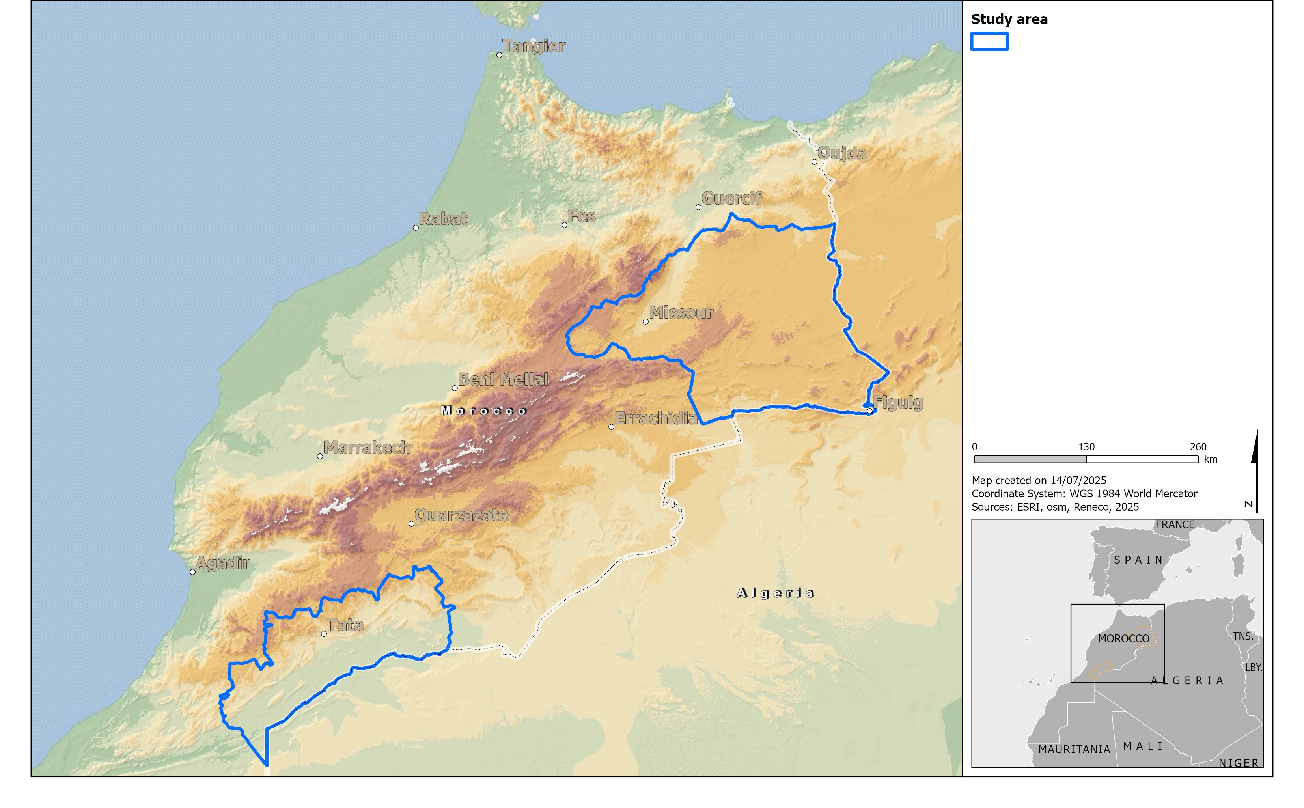
Figure 1: Study areas

A trained botanist can survey around 25 km² of steppe habitats in a working day. In reality, the surface area that can be inventoried per day is highly variable, depending on the accessibility of the area concerned, its relief (slope, gullies, etc.), the abundance of tracks and the diversity of habitat types.
Accordingly, the study areas are divided into 5x5 km grid cells, corresponding to subdivisions in four parts of MGRS 10x10 km grid cells (MGRS gridding was done according to Universal Transverse Mercator - WGS84 geodetic system) grid. Phytosociological study is conducted within these grid cells. The cell naming follows an adapted MGRS nomenclature (Fig. 2):
- The zone and the latitudinal band are omitted (we do not need them to ensure the unicity of the grid cell names in our working areas).
- The 5x5 km quadrant is added.

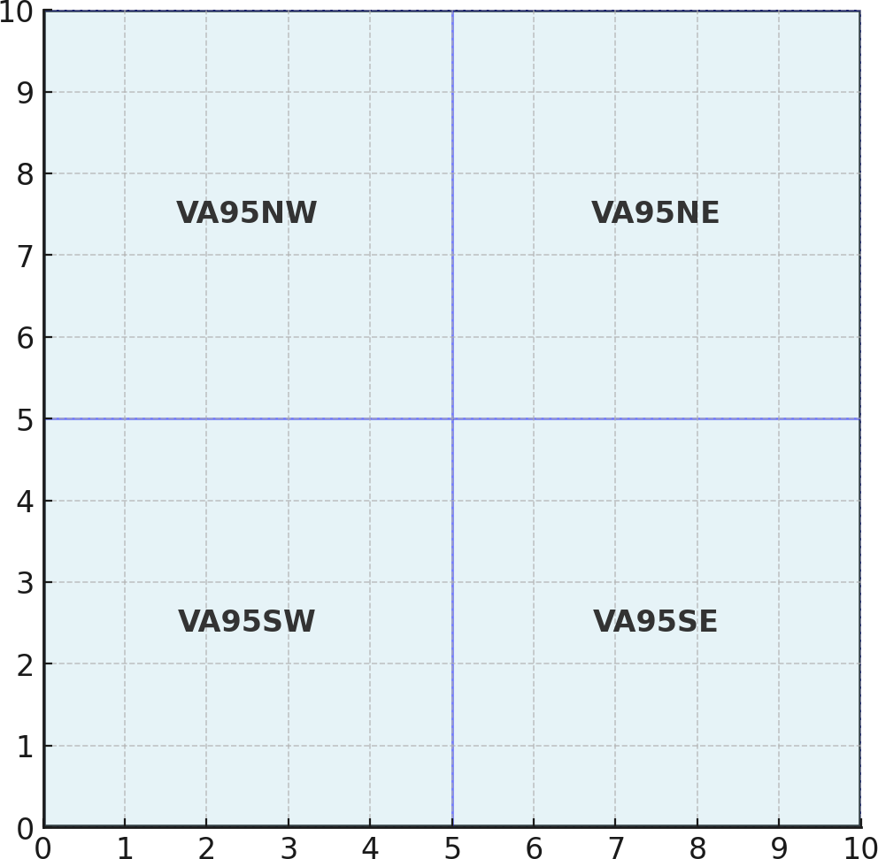
Figure 2: Example of 5x5 km grid cell naming (10x10 km MGRS grid cell 30SVA95 divided in four quadrants)

Sampling strategy and plan
A comprehensive inventory of all the grid cells in the study areas is unfeasible due to its vast size (> 70,000 km²). Therefore, this study is based on a sampling plan designed to optimize the inventory effort. The sampling strategy includes:
- Optimization of the sampling effort:
It is impossible to survey all the grid cells with the human resources available, due to the size of the study areas. In addition, given the large size of some habitat units and the habitat homogeneity over great distances, surveying each grid cell would result in virtually redundant information. So, we designed a sampling plan spacing the inventory at one grid cell out of every four (Fig. 3).
- Systematic sampling:
Grid cells are selected in a regular pattern. This prevents human bias as selecting easier grid cells, or more interesting ones, etc.

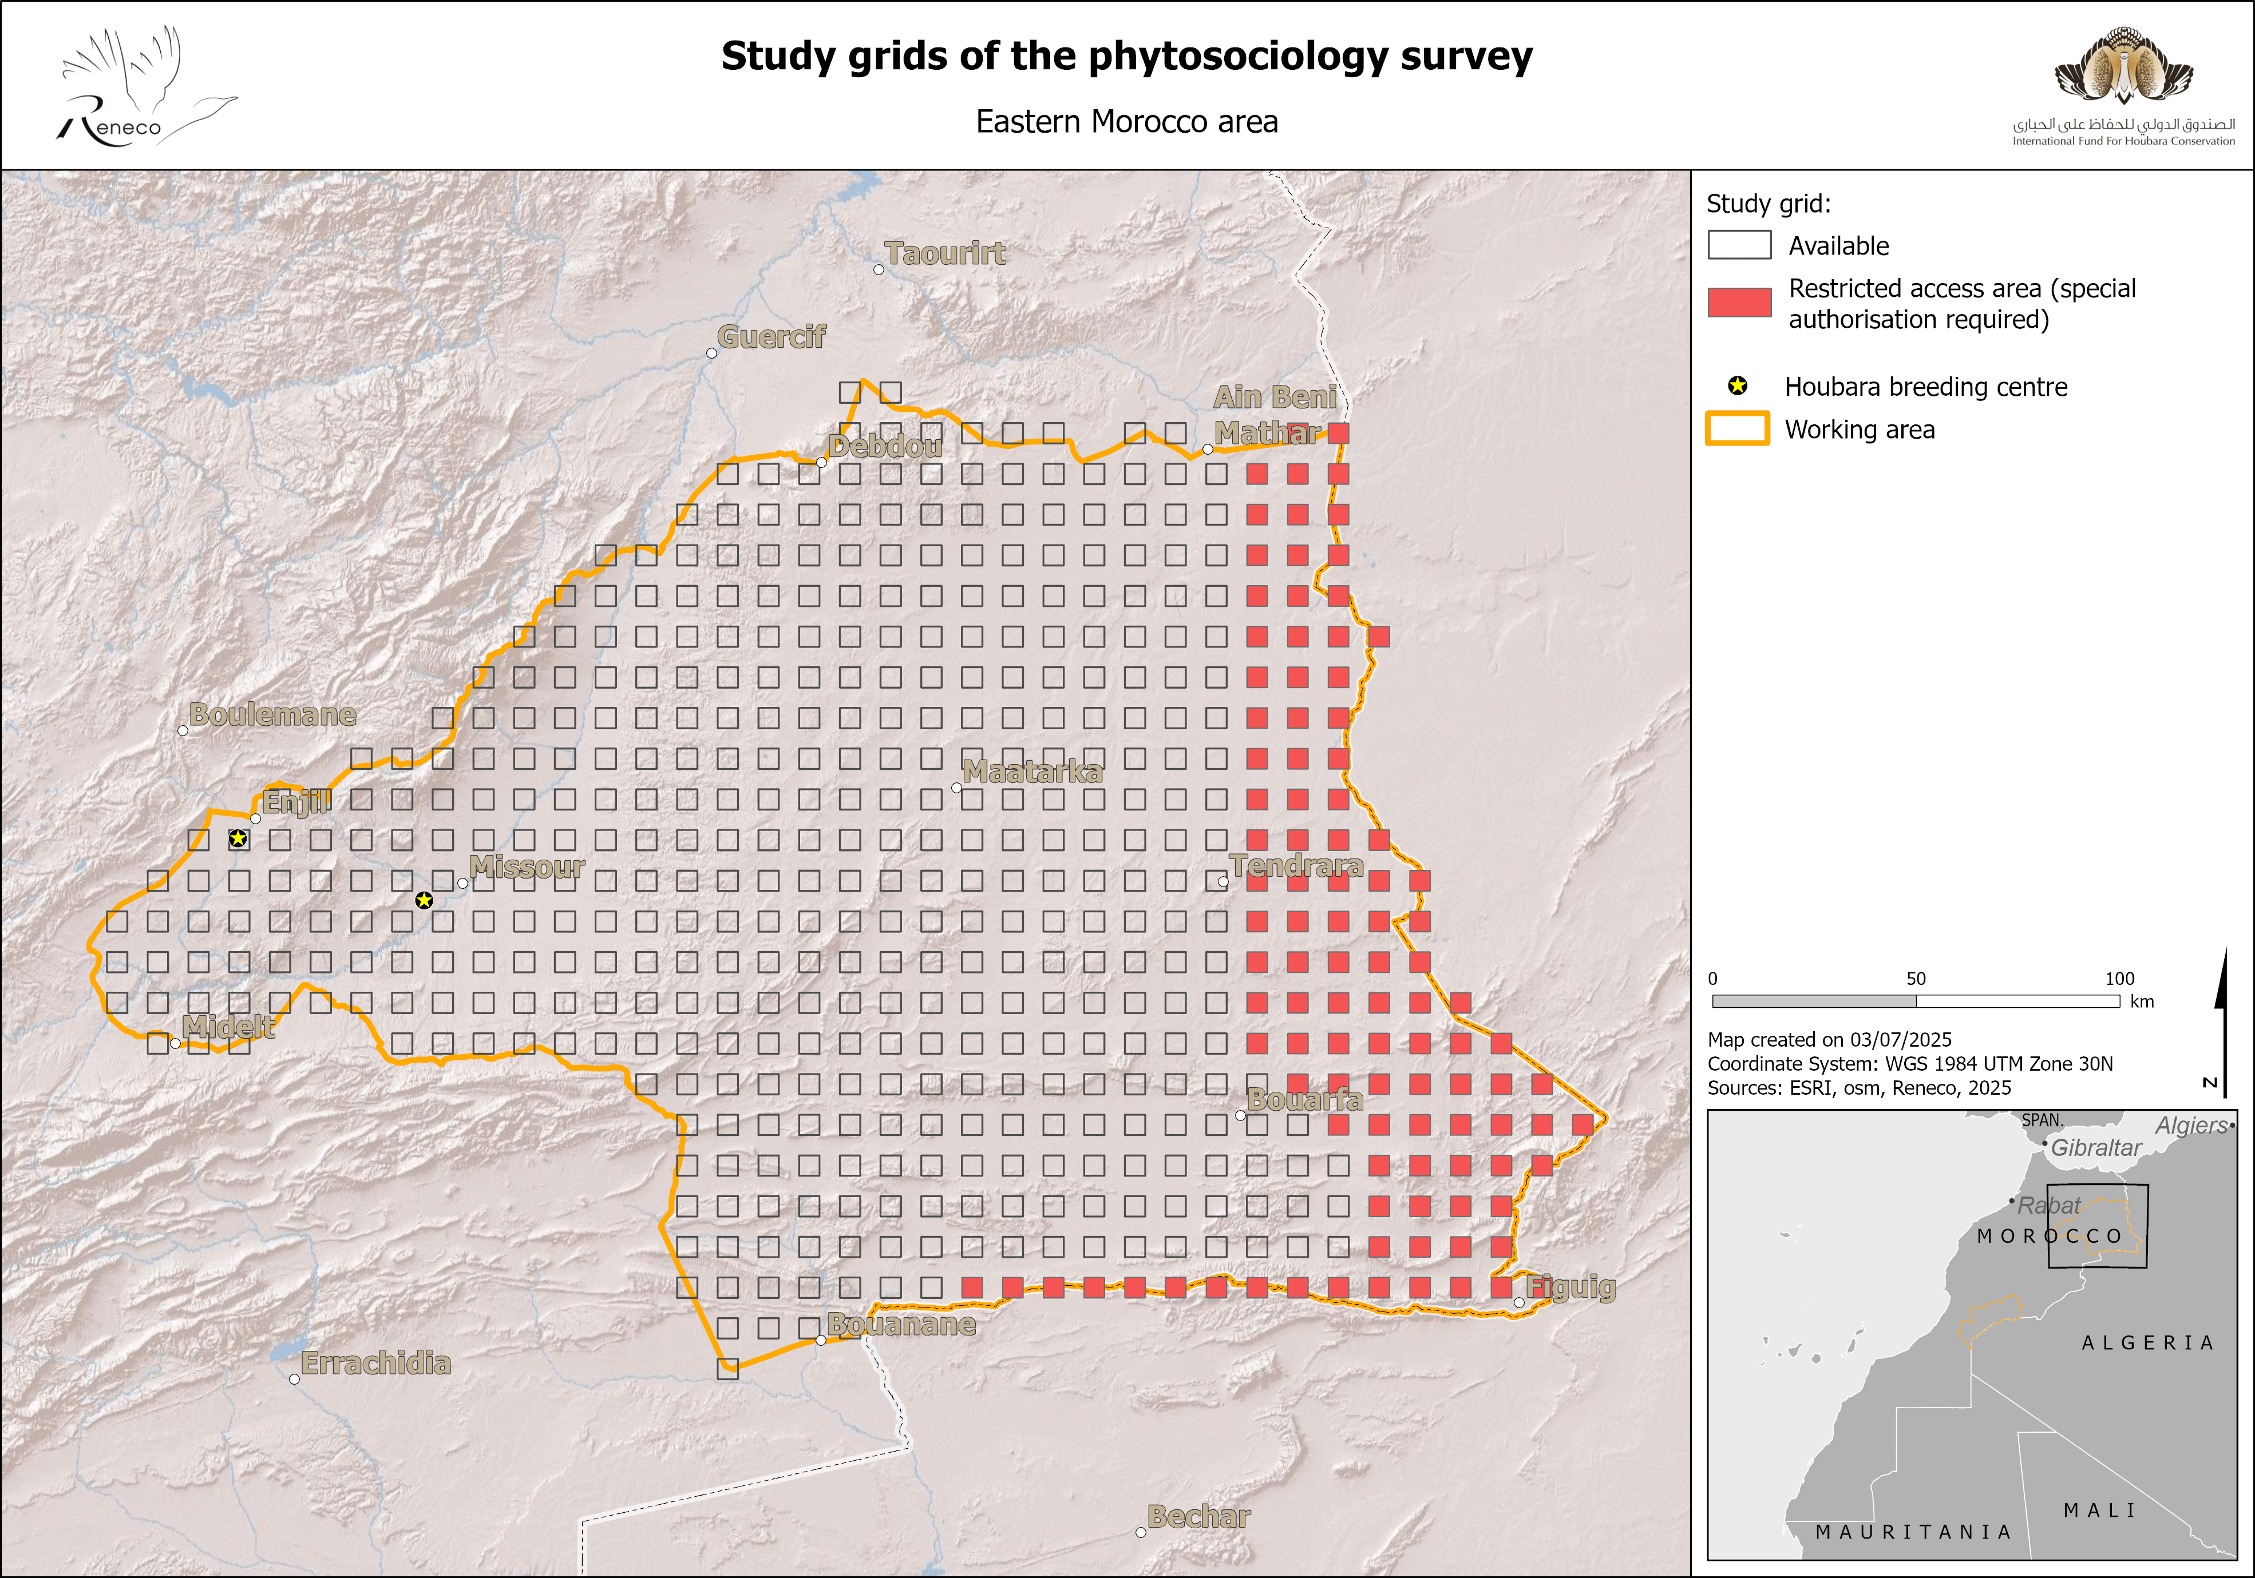

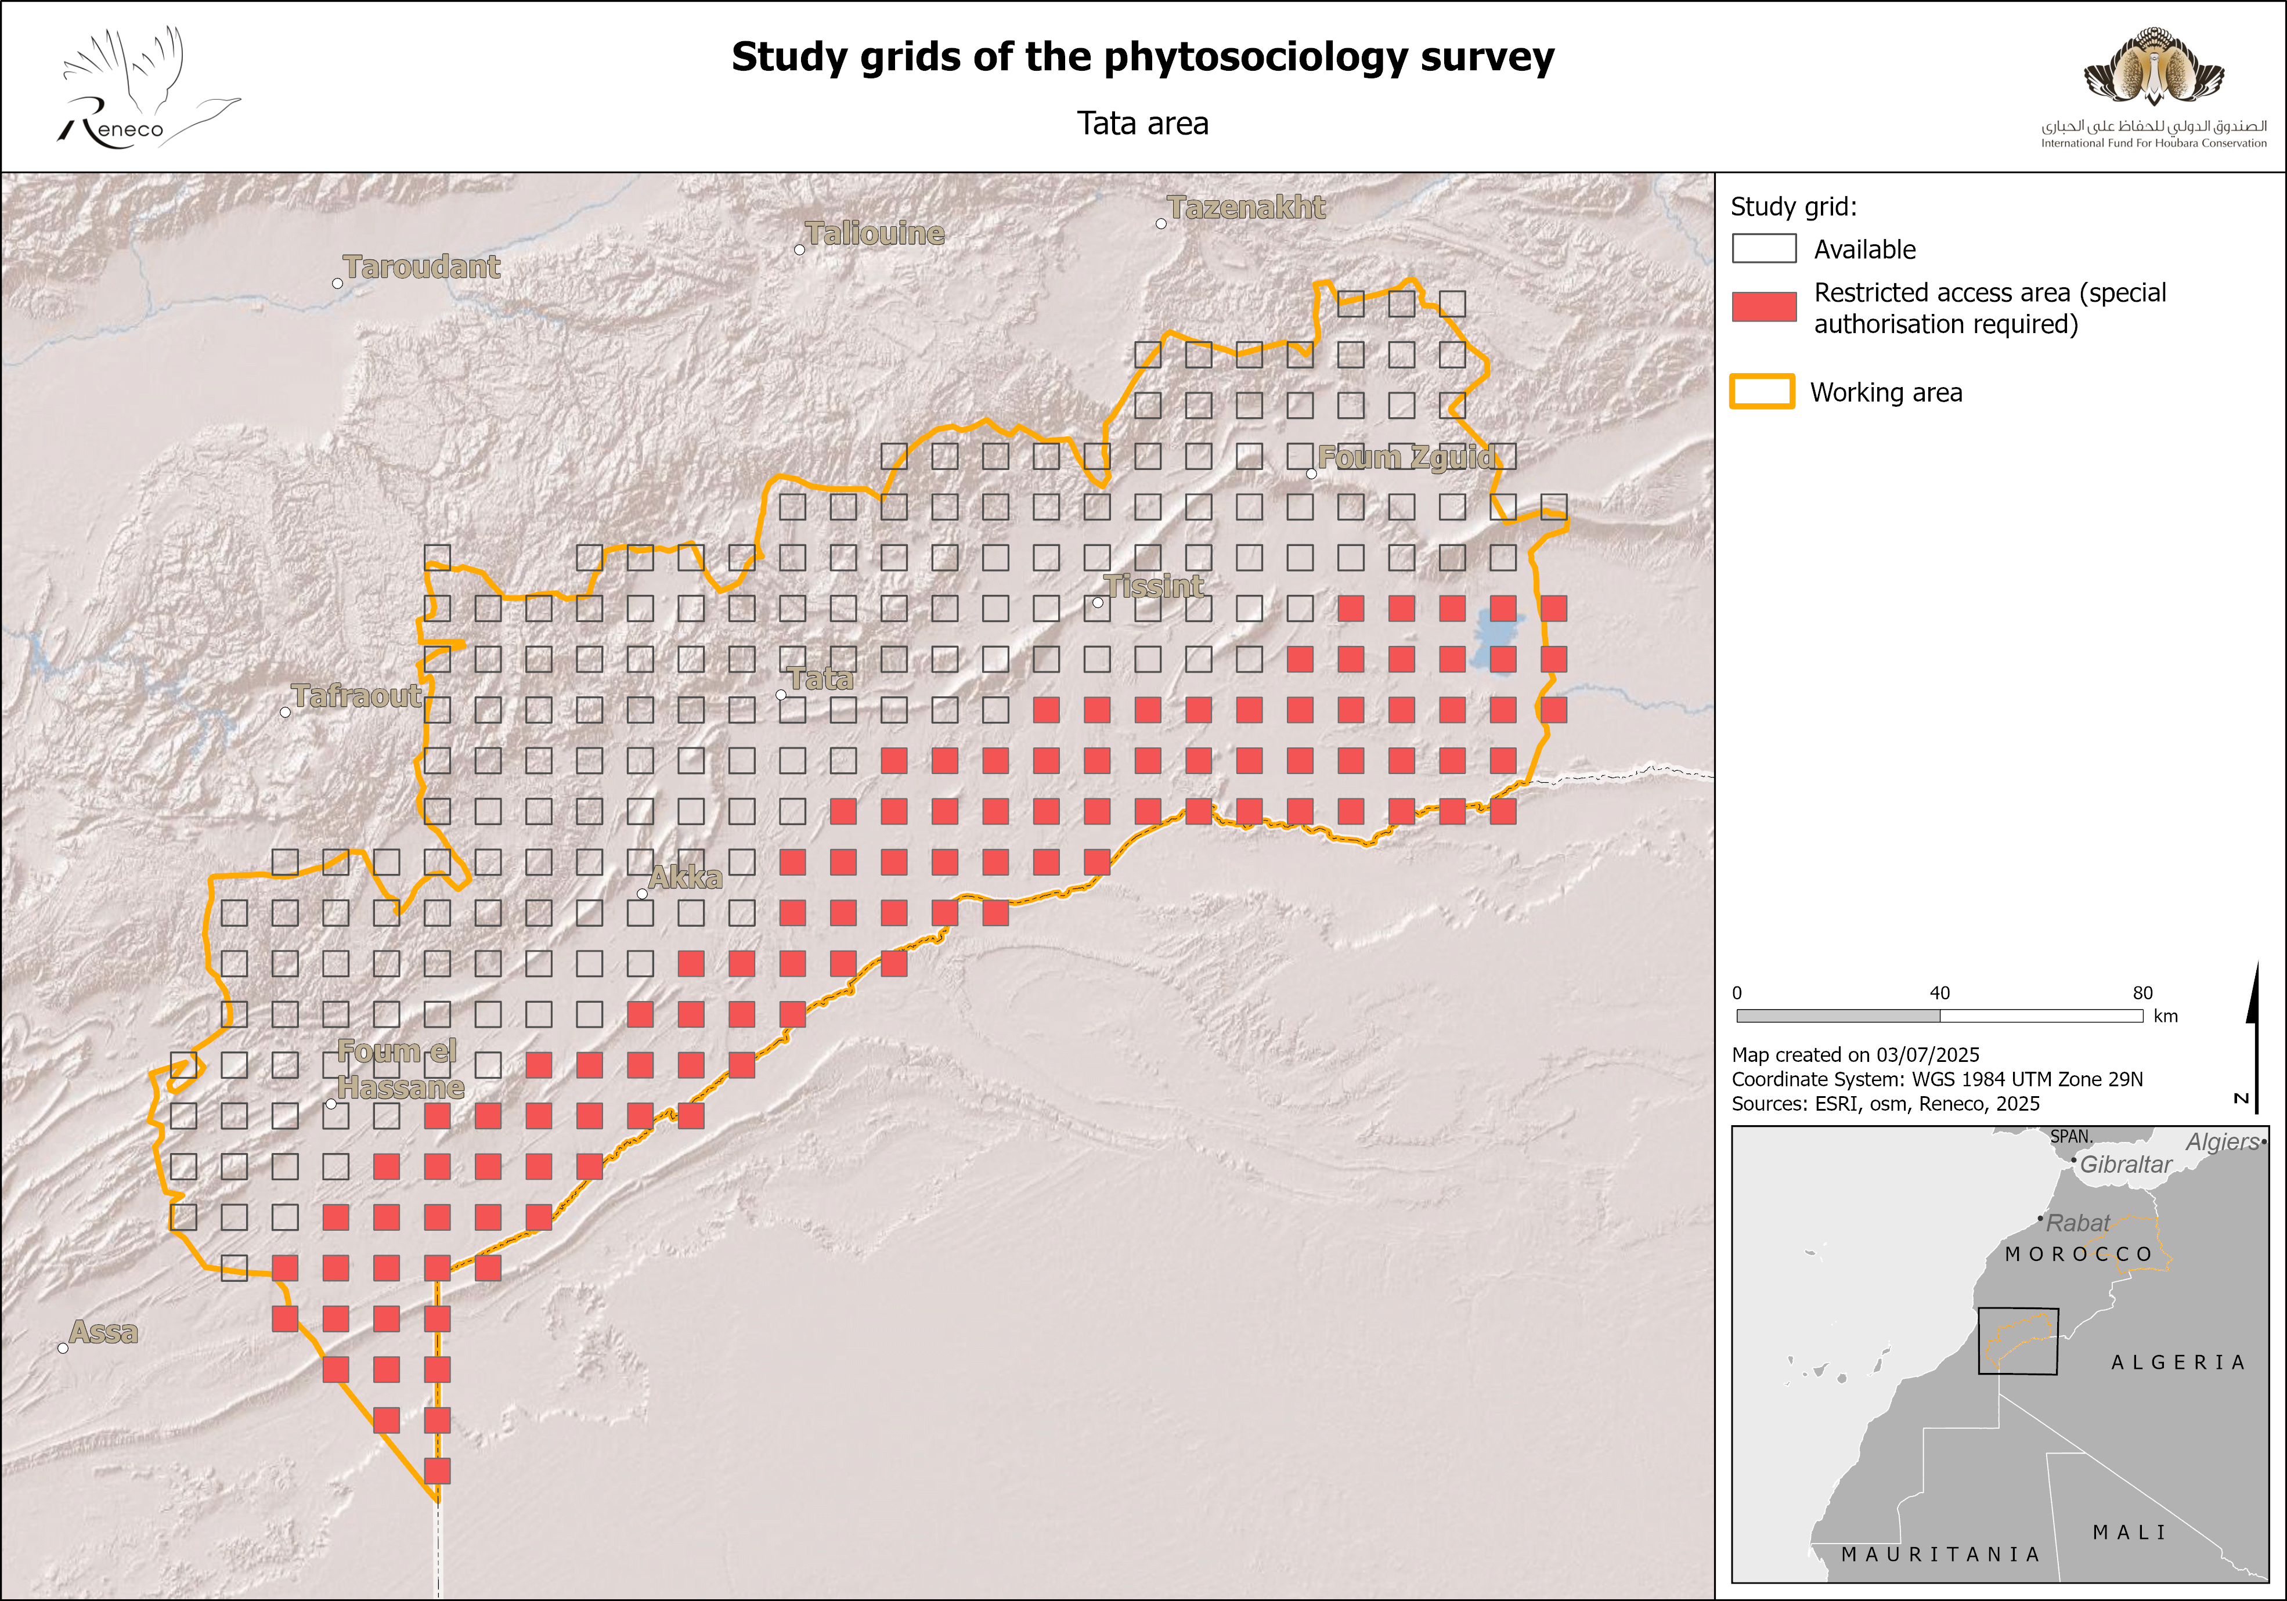
Figure 3: Theoretical location of the grid cells to be inventoried in the two study areas

- Stratified sampling:
Within each inventoried cell, all the habitat types, including the minor ones in terms of coverage, are surveyed by at least one phytosociological relevé. Satellite imagery is used to prepare the itinerary inside each sampled grid cell, and reduce the risk of missing minor habitats.
NB: In some area, all grid cells have been inventoried, for several reasons: The survey method was not definitely established, droughts implied that only small areas could be surveyed whereas botanist manpower was plentiful, etc.
NB: Access to grid cells located near the Algerian border is restricted for military reasons. They cannot be inventoried without special authorisation from the Moroccan authorities (Figure 3).

Study planning
The irregularity of the Mediterranean and Saharan climates has marked effects on flora, especially on the germination of annual species, which may be virtually non-existent during very dry years. Thus, fieldwork should be carried out only if the vegetation is developed enough (especially annual taxa). So, the choice of areas to study during a growing season depends essentially on favourable weather conditions during the second half of autumn and winter, and the development of the vegetation they allow.
Inventories must be conducted during the peak vegetation period, i.e., spring:
- Tata Province: (Mid-) late January to early (mid-) March.
- Saharan Atlas (Bouanane - Bouarfa region): (Early-) mid-March to mid (late-)April.
- Eastern Morocco: Mid-April to end of May.
- Foothills of the Middle and High Atlas + Eastern Moroccan mountains: Early May to late June.
Many taxa present their flowering or fruiting stages out of the main period of phytosociological inventories (summer, autumnal or early spring flowering or fruiting taxa). Thus, their identification cannot be done during the spring phytosociological relevés. These taxa therefore require dedicated additional field missions, targeting a selection of the plots where these plants were found during the previous spring. These plots are chosen after their accessibility and the probability that the concerned plants can be easily find again. This concerns mainly:
- Apiaceae and Cardueae (Flowering/fruiting in June-August),
- Chenopodiaceae (a key family of steppic habitats), whose fruiting occurs in autumn (October-November).
- Autumn bulbous taxa (September-November).
- Late winter/early spring taxa, especially the genera Gagea and Romulea (February-March).

Field study

Requested material for field survey
The botanist takes in his or her 4-wheel drive car:
- A mobile phone.
- A GPS receiver with the coordinates of the squares already uploaded (and, if necessary, tracks to reach them).
- A GPS receiver power cords + extra batteries.
- A camera with macro photography option (pictures of plants and habitat).
- Enough phytosociological relevé sheets for the duration of the mission (Annex 1).
- Satellite imageries of the squares (satellite imagery providing a grid with coordinates every UTM kilometre + higher and lower elevation points).
- A backpack (size suitable for carrying the herbarium press).
- Equipment to collect plant samples (pruning shears, plastic bag).
- Herbarium equipment (herbarium press and belts, newspapers, cardboards).
- Herbarium labels.
- Scissors.
NB: If the mission lasts several days, extra newspapers and cardboards must be taken (change of papers during the drying process of herbarium specimens).

Field prospections
Access to inventoried grid cells and itinerary inside them is done by vehicle or, sometimes, walking (depending on accessibility), but phytosociological relevé is done walking, aiming for comprehensive inventory of both habitats and taxa.

Vegetation homogeneity
Vegetation relevés are carried out in a patch of vegetation that is floristically homogeneous, without significant differences in species composition across its extent (GUINOCHET, 1973).

Data collected in each phytosociological relevé
The phytosociological relevé includes these data (see form in Annex 1), in bold those that are mandatory:
- Station name (a station is a plot associated with a date), chosen by the botanist (e.g. “VA95NW3” for the 3rd relevé made in the grid cell VA95NW).
- Precise GPS location (WGS84). GPS coordinates must be recorded, if possible, at least 40 meters from the edges of the relevé area or, ideally, at the center. Indeed, the GPS accuracy is somewhat variable, as is the georeferencing of satellite imagery. Therefore, when using the GPS location of a habitat relevé for the purpose of habitat mapping, it is necessary to take the coordinates sufficiently away from the edge of the habitat, in order to avoid positional errors that could place the point within a neighbouring habitat. The GPS-reported accuracy must be less than 8 meters. Small habitats (<80 m in width) must be clearly indicated on the data sheet.
- Elevation (in meters, read on GPS receiver; it can be checked against a DEM a posteriori).
- Slope (estimation in degrees).
- Exposure.
- Geology.
- Soil texture.
- Average depth of the water layer (the day of the relevé) – only for wetlands’ habitat types.
- Biotic or anthropogenic factors (disturbance, grazing enclosures, etc.).

The record must also provide a summary overview of the habitat unit:
- Vegetation series to which the relevé belongs (if the botanist has the expertise and knowledge required).
- Vegetation physiognomy (eco-physiognomic approach).
- Average height of the trees/shrubs, if the cover of woody plants exceeding 2 m in height is >50%.

The vegetation record includes the following information:
- Relevé date.
- Fieldworker(s).
- Surface of the relevé (in m²).
- Overall vegetation cover (%).
- Abundance-dominance of each taxon (Figure 4), recorded using the following coefficient:
  - 5: Cover > ¾ of the studied area (>75%)
  - 4: Cover between ½ and ¾ (50–75%)
  - 3: Cover between ¼ and ½ (25–50%)
  - 2: Cover between 1/20 and ¼ (5–25%)
  - 1: Cover < 1/20 (<5%)
  - +: Rare individuals, very low cover
  - r: Very rare individuals, negligible cover

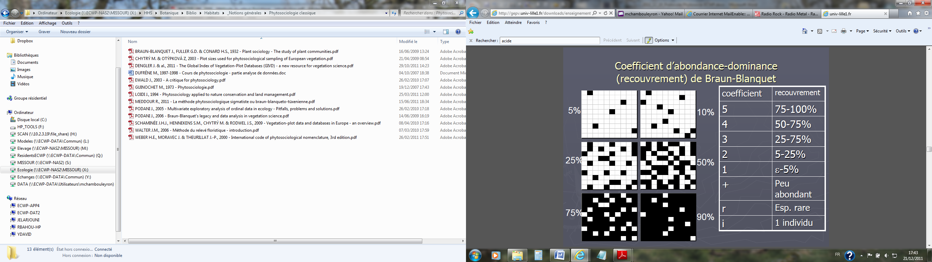
Figure 4: Schematic representations of abundance-dominance coefficients (Left: WALTER, 2006)

- Sociability (= aggregation) of each taxon (Figure 5), rated using the following coefficients:
  - 5: In great crowds
  - 4: In small colonies
  - 3: In small patches
  - 2: In groups
  - 1: Isolated individuals

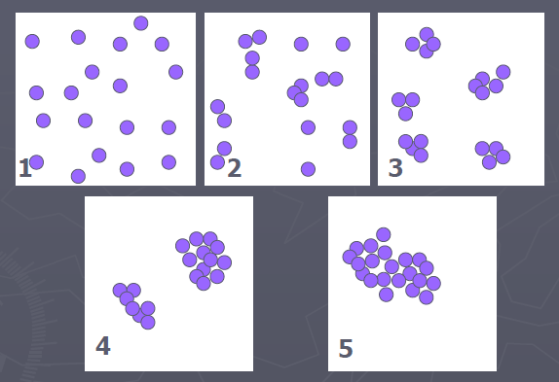
Figure 5: Schematic representation of sociability coefficients (individuals’ aggregation)

NB: Given the predominance of steppic habitats in the ECWP study areas, it is not necessary to record data by layer (tree, shrub, herbaceous, moss). The relevé encompasses all the layers present.

Prevention of pseudo-replication
Within each surveyed grid cell, each habitat type must be covered by at least one phytosociological relevé. The botanist has to do several relevés in the same habitat type when it seems necessary (e.g. different habitat facies or he/she is not sure that different habitat units represent the same habitat type, in case of an interesting plant discovery, etc.).
Nevertheless, the botanist should refrain to do virtually redundant phytosociological relevés (i.e. pseudo-replicas). Multiple relevés in the same habitat unit are strongly not recommended. Relevés done in different units of the same habitat type, should be spaced more than 500 m apart.

Additional plant observations
In addition to the phytosociological survey, the field prospection of the grid cells aims to produce a botanical inventory of each cell. Thus, during the phytosociological study, observations of taxa not listed in the relevés should be recorded, without recording their abundance-dominance and sociability coefficients, but with basic information (date, coordinates, elevation, etc.).
As the botanist circulates between surveyed grid cells to reach them, he/she is encouraged to perform opportunistic records of interesting plants (rare taxa, forest relics, etc.).

Plant collect
Many taxa observed must be collected (herbarium specimens) for identification in the laboratory, since 1) Moroccan flora remains insufficiently known (many new species still discovered), 2) many groups are impossible to identify on the field.

Data entry
Data are entered into the software ‘ecoReleve’ (developed by Natural Solutions). The user has to create a new station (“New station”) under the Field Activities “Phytosociology relevé”, or “Plants inventory” for additional plant observations.

Bibliographic resources
The fundamental basis of phytosociological work is the bibliographic analysis, which must target all phytosociological and biogeographical publications related to the Maghreb.
For this purpose, a file referencing all the missing publications is archived at X:\HHS\Botanique\Biblio\Publis intégrées en 2011_Stratégie, Factures, budget. This file is named: "2011_09_27_Biblio importante à récupérer" (Important bibliography to retrieve).
The publications are classified in order of priority. Their retrieval (PDFs, book purchases, scans, photocopies) must be scheduled annually.
Likewise, the file should be regularly updated by keeping informed about the latest publications and works.

Supplementary documentation
Phytosociology relies notably on environmental parameters such as climatology and geology. For this purpose, various documents must be acquired:
- Geological map of the study areas.
- Climatological data.

Scientific partnerships
To publish the collected phytosociological results, a partnership with a renowned phytosociologist should be considered to validate the data and their interpretation. The focus will be on phytosociologists with a good knowledge of the Maghreb, particularly the High Plateaus and the northern Saharan margin. This work can be done with the support of a PhD student.

References

ALLORGE P. (1922). Les associations végétales du Vexin français. Lesot.

FENNANE M. & IBN TATTOU M. (2005). Flore vasculaire du Maroc, inventaire et chorologie. Vol. 1. Travaux de l’Institut Scientifique, Rabat, série Botanique 37.

GUINOCHET M. (1973). Phytosociologie. Masson & Cie Editeurs.

MEDDOUR R. (2011). La méthode phytosociologique sigmatiste ou Braun-Blanqueto-Tüxenienne. Auto-edition.

WALTER J.M.N. (2006). Méthodes d’étude de la végétation. Auto-edition.

Annex 1: Phytosociological relevé sheet
(presented on a separate page for printing purposes)

Nom du relevé : |  | Latitude :
Secteur : |  | Longitude :
Date du relevé : |  | Pointage à au moins 40m du bord du milieu (préciser si habitat <80m de large)

Observateur : |  | Recouvrement végétal (%) :
Altitude : |  | Géologie (pH) :
Pente (°) et exposition : |  | Texture du sol (sable-limon-argile) :
Surface du relevé (m²) : |  | Inondation (profondeur de la lame d’eau) :
Facteurs biotiques ou anthropogènes :

Série de végétation :
Typologie de l’habitat : | Photo de l’habitat prise in situ :
Hauteur moyenne de la végétation arborée (à noter uniquement pour les forêts : recouvrement arboré >50% + hauteur arbres >2m + taxons sylvatiques et sciaphiles) :

